. Exercise 1-1

. I went to the success stories and was reading about how Python is used in ship building systems through streamlining API processes.

. Exercise 1-2

. I took off the p in 'print'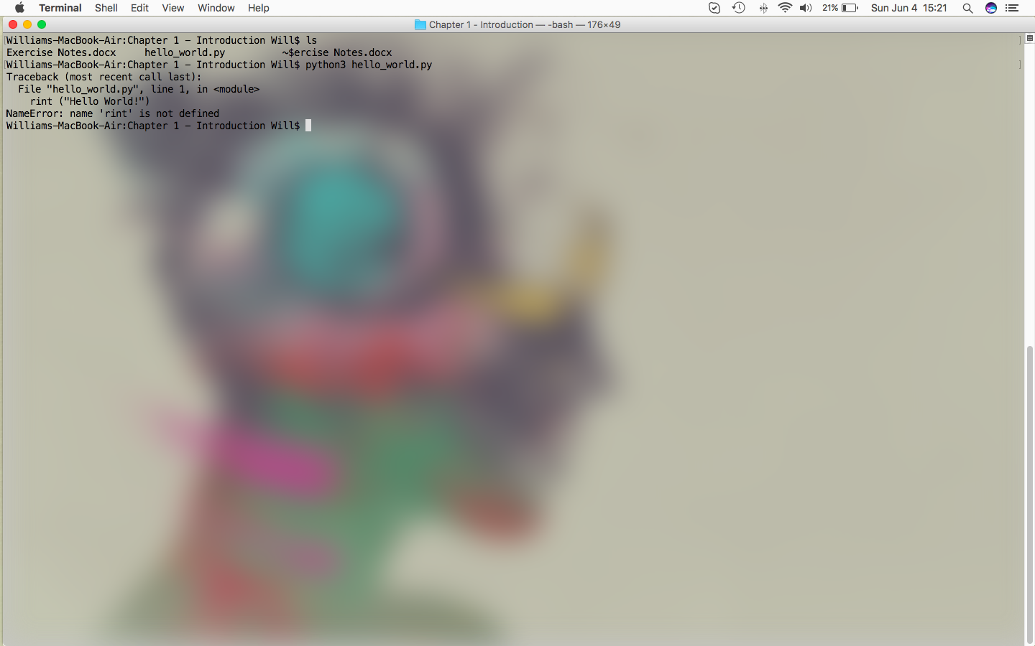

. The error was easy enough to identify given the error message from the interpreter

. For a typo that doesn't make an error, it'd probably have to be an out of bounds exception or something the interpreter might not catch. I'm not particularly sure how to go about doing this.

. Perhaps a misspelled variable name or something

. Exercise 1-3 (Infinite coding skills)

. If I had infinite coding skills, I'd build a virtual reality software suite. Like, a full dive.

. Three Project Ideas:

. A Euclidian Distance Calculator

. To compare performance with the one I made in Java

. Big Data Analysis

. Something that can search for correlation and provide statistical

analysis for a large data set

. Elliptical Graph Cryptography

. It'd be interesting to see the math behind such a complex set of

operations